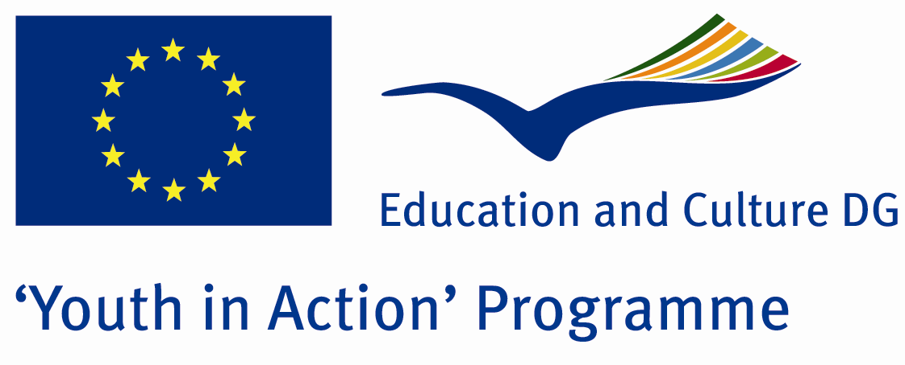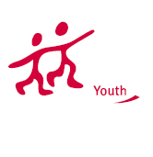

Does It Worth To Die - AIDS



ACTION 1.1 – Youth Exchange

07-13th July 2011

Aydın/TURKEY

Please contact directly to;

adventurerpeacepigeons@gmail.com

Project Summary;
This Project is about AIDS. The people who are AIDS, who carries AIDS or who are young and doesn’t know enough about the AIDS and to be careful against AIDS. Many of the young people doesn’t know about the AIDS or many of them don’t care about it. It is such an important disease that kills thousands of people every year. There are still many people joining to this group who are under risk of death ever year. We think that it is a very important theme to discuss and learn more about and take the interest of the others with this project. If you want to join us, please send your application form…

Project Title; Does It Worth To Die - AIDS

Date and Venue; 07-13th July 2011, Aydın/TURKEY

Target Group; Non profit/non governmental organization, Public body, Body active at European level in the field of youth (ENGO), Informal group of young people, e.t.c…

Participants; 5 people from each country (18 - 25). Totally 8 countries.

Conditions; Accommodation, board and programme costs will be financed through European Commission Youth in Action Programme (Action 1.1). Travel costs will be reimbursed in 70% (APEX Tarrifs). Organizations from all 27 EU member countries plus Liechtenstein , Norway and Iceland are eligible to take part.

Working language: English

Organizer; Discovery And Adventure Group

How to apply: If you are interested, please send your Part III forms to
0090 216 483 21 67 by FAX please. (Fulfilled Part III which you can find in the attachment, of course signed and stamped) ..

Note: jpeg is not allowed..please send by fax…

Next step 2;
Original send via regular post to this address please:

Ertan DERİN
Öner İnşaat
Abdulhalik Renda Cd.
Parlar Sk. No:4 Pendik/İSTANBUL

If you have any questions you may contact with: adventurerpeacepigeons@gmail.com

Deadline for application; until 20th January 2011.

For Further information:
Contact Person
Ertan DERİN
Öner İnşaat
Abdulhalik Renda Cd.
Parlar Sk. No:4 Pendik/İSTANBUL

e-mail : adventurerpeacepigeons@gmail.com
Mobile : 0090 542 393 93 90
Fax : 0090 216 483 21 67

